**APP TECH STACK**

**App Name:** DeputeX

**App Play Store Download Link:** https://play.google.com/store/apps/details?id=app.com.deputex

**Website:** https://www.deputex.com

-------------------------------------------------------------------------------------------------------------------------------------------------------------

**Technical Stack:**

Development Language

• Android (Native) - Java / SQLite

• Admin Panel & Web Services - Php Laravel / MySQL

• Admin Panel UI - Bootstrap Design

Servers (AWS server )

Server OS Platform

• Linux or Centos

Database (RDS server in AWS is advisable)

• MySQL

PUSH Notifications

• Firebase

Gateway

• Razorpay Payment Gateway

**LIST OF REQUIREMENTS:**

**1. First Milestone:**

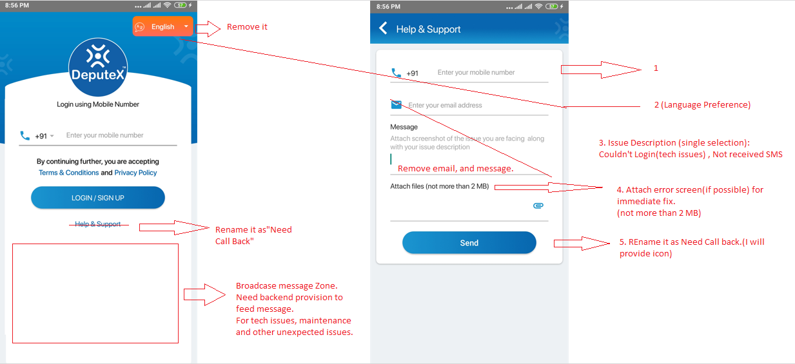

-In existing help & support table, add fields for language preference and Issue description, remaining all stays unchanged.

-Broadcast message backend provision.

-Table to capture focus change data in separate table

-When focus changes from mobile input field after successful validation, immediately it should store those numbers inside separate table.

*Once received OTP app should sense, fill, submit and then land in Home page without user interaction, Remove following screens during login time.

|  |  |  |  |  |  |
| --- | --- | --- | --- | --- | --- |
|  |  |  |  |  |  |

*Presently network discovery not integrated into app. Integrate present state, district, city location DB fields with google.

OLX similar screen and functionality required here. This has provision to select present location, previously accessed, and any place selection provision. In all forms where ever location field is there, they have to reflect this.

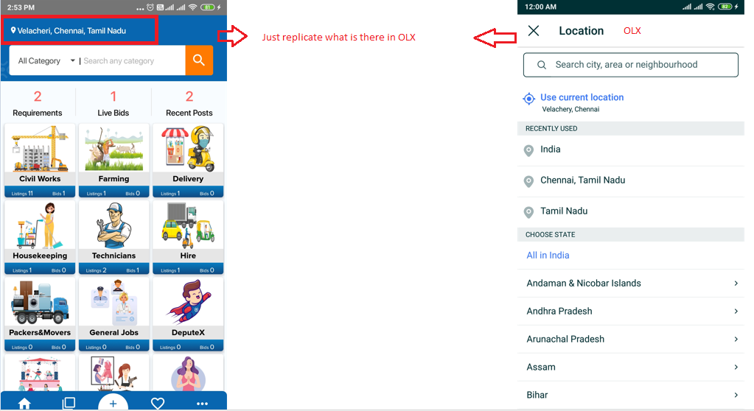

*Unregistered user when try to post after selecting input form, through popup windows we need to collect all his input fields in one form.

User Type > Individual, org. representative /service provider (represent a company/org./agency/service provider/business owner)

Individual> DP, Name, Gender, Email(optional), Aadhaar (Optional, Required only if you post voice note)

Org. User or Service Provider > DP, Org/SP Name, Org. Email, Upload provision for company incorporation certification, PAN, GST. If company is unregistered Provide Aadhaar copy to validate (i)-info icon need to add.

-mobile, location details we have already, so no need to collect it again.

Except above mentioned other fields not required, below mentioned five form will now appear in single one.

|  |  |  |  |  |
| --- | --- | --- | --- | --- |
| 1 | 2 | 3 | 4 | 5 |
|  |  |  |  |  |

*Notification to registered users whenever a new job/Post has been introduced on their desired category

-Backend provision to control this>globally switch off to all, link/unlink with Lead Pack

*Sort By:

-Ensure micro to macro expansion feature should work smoothly with Network based discovery

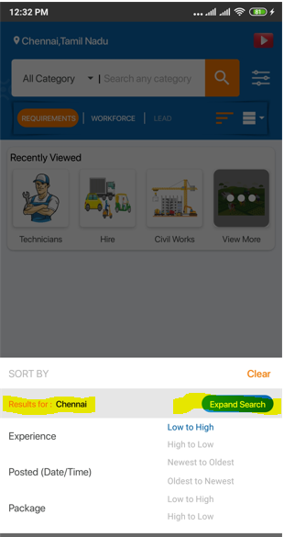

**2. Second Milestone:**

*Post Button:

Post requirement or Post My Profile options should be replace by three queries where still input form follows old one.

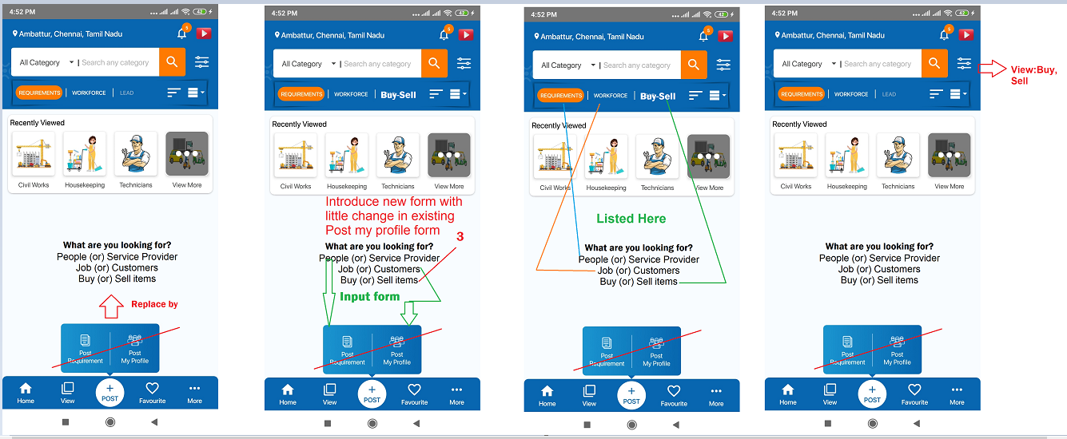

Note: Except old user, for all new users first time when they post on app we need to collect some basic profile information as shown on page3.

Buy (or) Sell >

-Buy/Sell Product (30 days validity) <individual users> form with duration

-Business Listing (for shops and business owners (retailer/wholesaler/supplier)) <org. representatives> form without duration.

While fill the basic profile details they will provide whether they are individual or business representative, based on their basic profile selection some of the options we may hide inside app. Eg: for individual user we don’t have to show Business Listing provision above. So, users will not see irrelevant items on their app.

*Where ever possible you may get these captions through backend. So, it could be changed in future easily.

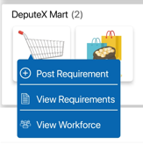

Remove DeputeX Mart from menu listings while selecting:

-People or Service Provider

-Job or Customers

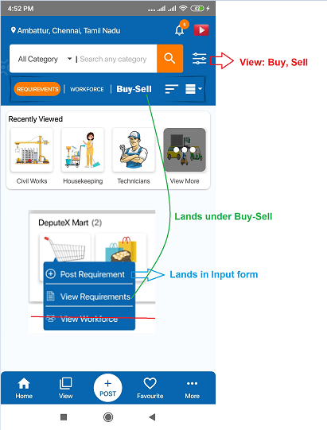

Inside Filter: Add Buy or Sell selection provision to facilitate Buy/Sell listing

Buy-Sell> Post requirement form fields:

Cat1, Cat2,Buy/Sell, Location, Languages, Voice Note/Description, Duration, Bid/Pricing, and rest are following.

Provision to integrate images to below forms:

Job (or) Customers

Buy (or) Sell items

When user select inputform> Buy (or) Sell items

It should show only DeputeX Mart

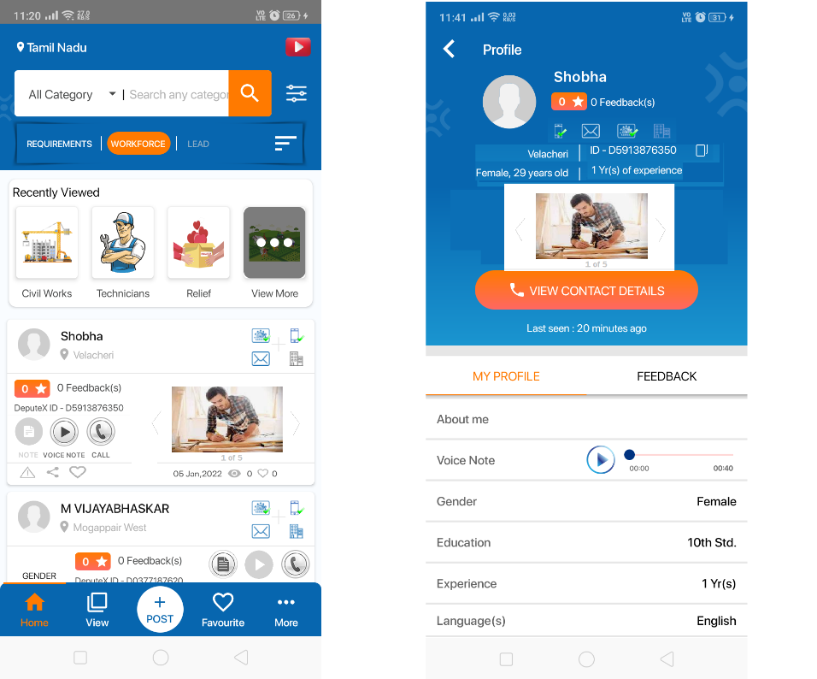

Small change in strip design

(listing under workforce)

Job (or) Customers

Buy (or) Sell items

Listing, and detailed screens need to accommodate pix slide show with small corrections. (like total number of tasks attended).Rearrange Pix order.

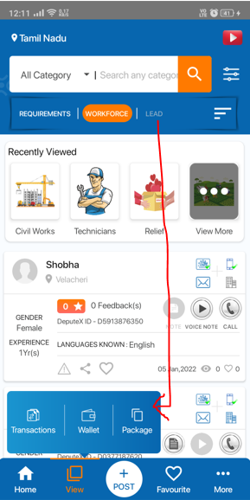

Replace Lead by Buy-Sell and move Lead inside View.

Move Lead button inside View, or you may suggest some good place it for easy access.

(4 Tabs)

Leads: Posts submitted under categories you show interest

Profile Viewed by: DP, Name, Authentication icons, fav, date time, post submitted: 1(count) with link

Call back Requests: DP, Name, Authentication icons, fav, date time, post submitted: 1(count) with link, Report

Fav to: who are all marked your profile/post as favorite.

**Call Button:**

-Presently who ever touches call button, after deducting credits it will show contact information and this contact information would be visible for next 7 days to user.

Going Forward, call button will act as call back in below mentioned screens.

-Inside workforce

Buy/Sell items:

-~~Buy/~~Sell Product (30 days validity) <individual users> form with duration

-Business Listing (for shops and business owners (retailer/wholesaler/supplier)) <org. representatives> form without duration.

Whenever user touches call back button, it will send call back request to the respective person and user will get ack msg for sending request.

-Change icon for call back, I will provide required pix.

-Remove call button related popup presently configured Msgs

-Even user press multiple times, only one call back request should be sent to person at other end(perday).

-If a spammer automate call back through bot, more than 50 call back within 1 hr (backend provision) >block him for 30 min>trigger mail to admin to cross check breach.

*Backend and Profile Provision:

Backend:

Create a backend provision to access all input forms by support staff. So, backend people can do all front end activities on behalf of some one who don’t have android mobile.

This form must contains mobile number and otp provision to validate every record introduced.

Also, Bulk upload provision must be there to do all these front end activities as bulk process through backend.

More >My Buddy:

Add Buddy > ☑

By enabling this, user may submit any input form on behalf of others

While accessing input form each time it will proceed from basic profile registration to other forms.

Before submitting a form it will ask for mobile number/OTP to create new account and introduce form

Call My Buddy>Give mobile number and just press call back button. It will create call back ticket to support team, and support team would address and close it. Introducer will receive all ticket communication like others for this open, closure, status, etc. through notification and sms. Ticket number generated popup windows and will be shown to the user.

Maintain a Buddy table: while will show parent child link to introducer and joiner. Followers count would automatically increase base on it. Eg: Parent No, Child No, Created Date& Time, Status

**3. Third Milestone:**

**Packages:**

-Remove bundle pack concept from all four packages

-Max. of packages purchased > provision should be given at back end for all packages to customize maximum count.

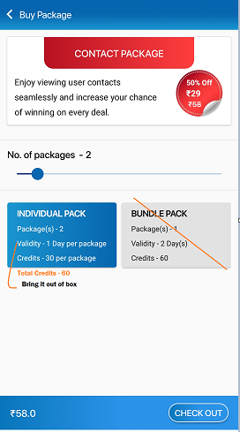

-Remove Bundle Pack Provision

-Remove Individual Pack Heading

Inside rectangle

-Package(s)

-Credits-

-Total Credits-

Out side rectangle

-Validity -1 day per package

-Contact pack validity not changes automatically inside description window

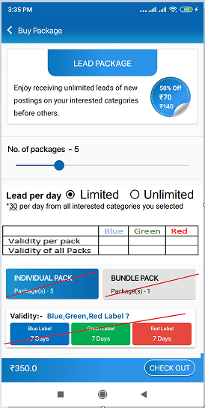

-Remove items crossed at red

-Add Limited, Unlimited Provision

Backend provision to input *30 per day count (max count)

-Presently, validity of lead pack remains same number of day. This needs to be configured as per colour value like in Priority Pack. (Backend provision for these values)

-Auto populate table values based on number of pack selected and validity per pack on each colour.

-Backed Price and Validity provision for limited and unlimited

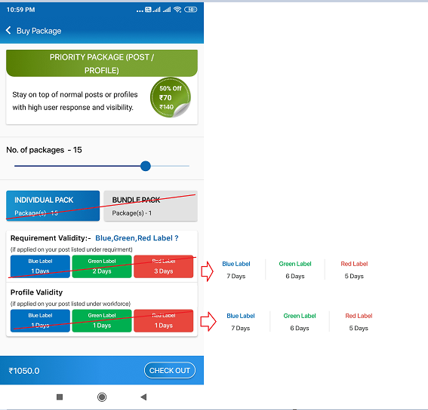

-Remove items crossed at red

-Convert validity values as shows, its already available inside just replicate same code here

-Presently, validity of Priority pack remains same number of day if applied on workforce profile. This needs to be configured as per colour value like if applied on post. (Backend provision for these values)

-Need to check auto renewal works smoothly with this change.

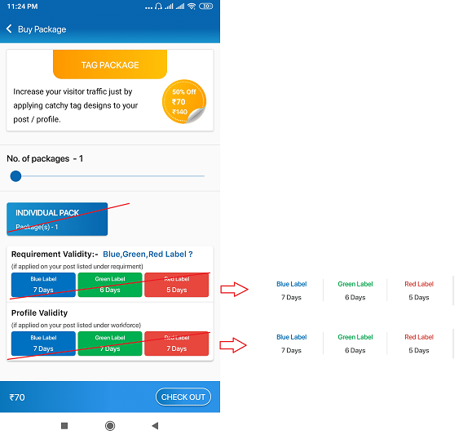

-Remove items crossed at red

-Convert validity values as shows, its already available inside just replicate same code here

-Presently, validity of Tag pack remains same number of day if applied on workforce profile. This needs to be configured as per colour value like if applied on post. (Backend provision for these values)

-Need to check auto renewal works smoothly with this change.

-Backend provision to pump more tag models inside app and remove existing.

-Package validity descriptive window need to retouch.

-Provision Add/Modify/Del tag and text through backend.

*Auto renewal of Lead Pack

After Expiry of : ⦿Blue 🌕Green 🌕Red

Auto renew by : 🌕 Limited Pack 🌕 Unlimited Pack

-auto renewal lead limited by lead limited and lead unlimited by lead unlimited.

**4. Fourth Milestone:**

*Home Page:

-Replicate gotop icon on left side with question mark, as screen guide button. There must be a provision inside More>Settings>Configuration, to show or hide this button. When ever user touch, it will shows components of the screen as below or in some other better way. Facilitate through backend to add/remove/modify guiding screens.

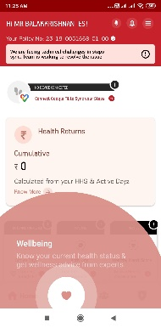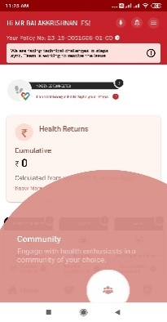

-Screen loading issue(loading icon) at home page listing, menu, sub menus and through out the app this needs to be checked and resolved by removing unwanted codes or by optimizing codes in effective way.

*Notification:

-Presently when we open message screen all unread automatically converts as read. It should change after we read it and unread messages count should show on top.

Need to put a filter to show all, unread, read, mark all as read, mark selected as read, msgs separately. Need provide facility to select all or particular message like tick marks to convert them as read/unread.

Change

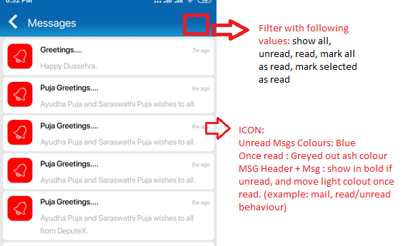

-Presently even people not posted getting the below message. Need to find inside code where are all these messages and need to fix it.

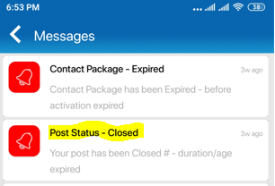

*Filter:

-While applying filter for selected category, no need to show the fields which are all not part of their input form.

Eg: Education field in plumbing input form, but filter lists out all input fields for every search.

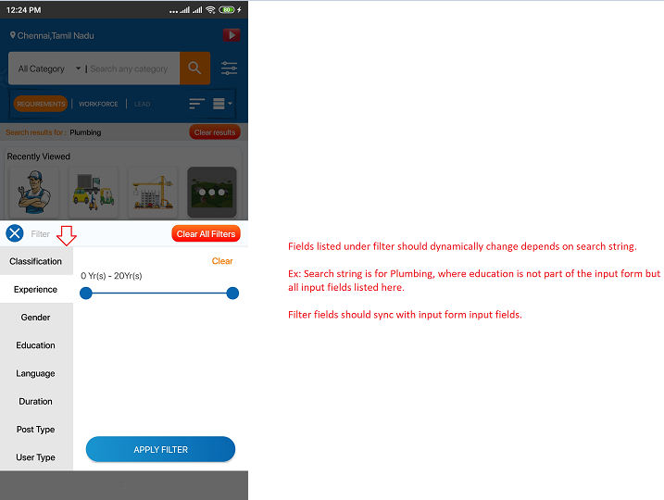

*FAQs & Video> change as Help

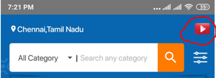

Help items should be in below format. Add provision for Language at backend so while changing language at front end it will get corresponding items.

|  |  |  |
| --- | --- | --- |
| Video Preview | Question: **How to use the app?** | |
| Answer : Inside app once you logged in… (more..) | |
| View Video | View Image |

*Search Bar:

-Show All Category search results on same page.

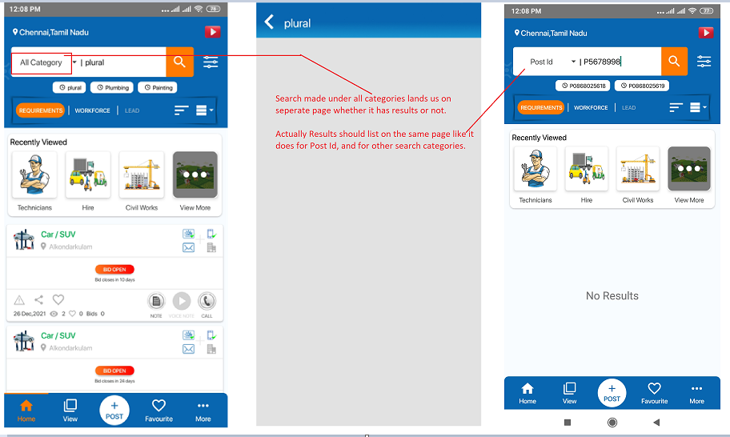

*Hide details of Bid user name, and other details

View>My Transaction>Posted>Bids

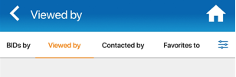

*Enable Privacy Lock for all users. Presently this menu appear only to user registered as gender:female, just remove this condition. So, it could be used by veryone.

More>Settings>Configuration

*AD banner provision as per excel sheet requirement. Already backend and coding has been done for the same. It needs to be just tested and stabilized.

*Clear screen loading issue in all screens by optimizing code wherever required.

-Ensure Picture, Video, Audio note are all stored in compressed format only.

*Analytics API integration with App (zoho or segment)

*Workforce - Profile disable provision

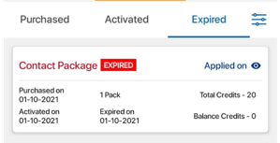

⭳

⭳ Download next to pack, it should download invoice of the purchase on touch.

Maintain invoice table to populate the values of each purchase.

*More>Settings>Special Services

Provision to enable this for selected users only. It will contain tabs namely

Tab1: Advertisements Tab2: Top 5 Posts Tab3: Sponsored Posts Tab4: Lead Booster

Layout provision will be given shortly, to place inside each tab.

* Animation effect on menu transition where ever possible especially, on home page.

* Try animated own loading symbol, animated app first page.

* While posting user without aadhaar verified must submit description. This may be skipped if their aadhaar is under verification status.

* Location double time present on post my profile form, need to correct.

Backend Form:

-To find user/posts/profiles introduced, duplicate identification, etc.

-Bulk duplicate number finder.

-mobile, mail id <check availablility>. -if same number already exist it should not allow support people to add the service provider again.

-Backend form should have provision to do individual or bulk search based on mobile, name, mail, aadhaar, deputex id. So, same user data will not get uploaded twice. (presently its is partially available under MIS>User>User settings)

This form should have provision to merge selected replication.

-dashboard provision to know whether this phone number related any profile, post already existing, new , or old number. View> Profile, Posts, Advertisements, due dates, etc

-Profile market as field staff could not redeem followers credits, the mobile number/unique id given to him by backend people.

-On boarding banner, coupons pix

-Couldn’t remove inactive videos at front end, need to check.

*Backend provision to disable screen shot provision through out the app

Images: Standard 5, provision to add more number or video provision through backend handling. (video-duration-count)video separately. In backend all these must be stored in compressed format.

Report for all newly introduced items.

-Allow user to override a pack by other after OTP confirmation. small validity pack by higher

Website:

-Email integration, unsubscribe option

newsletter, blog, wishes sending provision.

onboarding welcome email integreaton to app.

- Captcha integration in website submission form.

-website, app popup msg

Small Bugs:

-No sim error at login page

-Screen issues on certain models/Device oriented screen malfunction.

-log file capture

-404 error in mis report>users>users settings

-Navigator bar Orange focus not changing (view button)

-Weekly once app review popup for non reviewers.

-DOS/Bot Attach, crawling – how to avoid?

-------------------------------------------------------

General Note:

-Examples and screen shots provided here are for demonstration purpose, you may enrich it with new ideas design, and way of presentation. Pls. don’t just copy and paste any data try to provide aesthetic touch.

-Integration of backend reports to new add-ons.